Global Cart Solution Design Document

Contents
Key requirements 2
Sales channel 2
Architectural overview 2
Component Communication 3
Technology stack 3
Real-time data processing 3
Scaling strategy 3
Security 4
Data protection 4
Services 4
External services integration 5
Porezna uprava (fiskalizacija) 5
Payment providers 5
Marketplace / B2B 5
Monitoring 6
Code delivery 6
CI 6
CD 6
DB 6
Branching 6
Provided demo 7

Key requirements
- Scalability and support for high traffic (millions of users/day).
- Secure transactions and data protection.
- Real-time data processing.

Sales channel
- Web shops
- Mobile apps
- Marketplaces
- B2B integrations

Architectural overview
To achieve the demands an event-driven, microservice archicture is chosen. Each service has it's own database for context, with async communication between services and shared gateway to handle traffic.
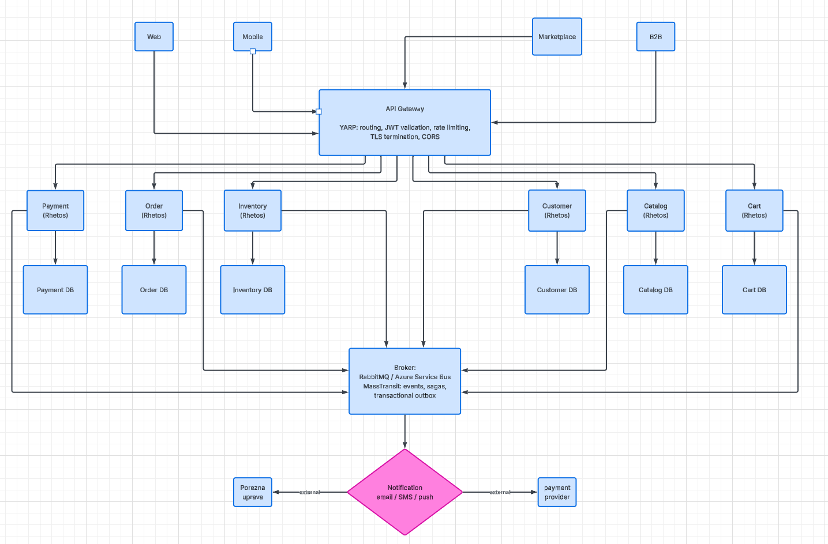

Component Communication
From | To | Description
Client | Gateway | HTTP via rate limited gateway as the entry point
Gateway | Service | Request forwarding through gateway after JWT validation (+Forwards JWT)
Service | Service | State changes happen asynchronously through events. Receiving services update their local state.  + MassTransit for reliability

Technology stack
Area | Choice
Language / Environment | C# / .NET
Application layer | Rhetos for DSL domain models, EF, REST
Datastore | SQL Server
Messaging | MassTransit + RabbitMQ / Azure Service Bus
Gateway | YARP
Observability | Serilog + OpenTelemetry for distributed tracing
Deployment | Docker + Kubernetes for horizontal service scaling

Real-time data processing
Processing state changes as events enables fast handling with each service having snapshots of relevant intermediate states so requests don't need other services to prepare a response, while those snapshots are updated by event consumers.

Scaling strategy
The gateway allows the stateless services behind it to scale horizontally with additional pods for services. Database per service approach also decouples workloads per services which removes the bottleneck of a shared database and allows finetuning based on service's demand. Async nature of inter-service communication buffer spikes on the message broker instead of overloading downstream services. Caching can be added via CDN for static content and Redis for user carts.

Security
Authentication via dedicated identity provider which on successful authentication provides clients JWT access tokens. Gateway validates JWT and rejects invalid requests before they reach any of the services, and valid requests get forwarded to the called service, revalidating the JWT and mapping the claims relevant in the service's DB. Rhetos additionally enforces row permissions to prevent users from reading other users' data.

Data protection
Parameterized queries (Rhetos build artifact) to prevent SQL injections. Secret store in a vault (eg. Azure Key Vault). DB users that will run on the service also need to be created with least amount of DB priviledges to function. Payment related data should be delegated to PCI-compliant providers and should not be kept locally, with idempotency keys to prevent double charging on retries.

Services
Cart (rhetos) – handles shopping carts and items, invokes checkout
Catalog (rhetos) – handles product categories, products and product data
Order (rhetos) – handles the order lifecycle after checkout
Inventory (rhetos) – handles stock (availability and reservations)
Payment (rhetos) – handles payments, refunds and payment providers
Customer (rhetos) – handles customer profiles and personal data
Auth – handles user authentication and JWT token creation
Notification – handles Email/SMS/push notifications
Gateway – handles service routing, JWT validation and rate limiting
Shared – handles shared DTOs between services for communication

External services integration

Porezna uprava (fiskalizacija)
Built within the context of Order/Payment services. Signs and sends fiscalization request and stores returned JIR/ZKI. Runs asynchronously after OrderConfirmed event with retry. This way a slow or unresponsive endpoint won't block checkout.

Payment providers
Adapters for providers built behind the payment service.

Marketplace / B2B
Dedicated adapters to map/translate client payloads into internal events. Gateway can provide additional support here by rate limiting and version checking the payloads.

Monitoring
Each service exposes liveness and readiness endpoints which can then be consumed by Kubernetes. OpenTelemetry can be fed into a monitoring system (Prometheus) with distributed tracing across services.
Logging is handled by Serilog on service level which feed the data into a central store

Code delivery

CI
Performed on a per service level, includes restore and build processes, unit/integration tests, rhetos database update against a temporary container, static analysis and a project build.

CD
Progressive delivery via canary/blue-green (per service as deployments are service independant).

DB
DB Migrations ran as a pre deploy step, backwards compatible to enable both versions of the services to run during rollout.

Branching
Short lived feature/task branches that get merged into assigned build branches. After a release, new branch is created for the new release from the existing one with new features developed being merged there.

Provided demo
OnCartSolution contains a working demo of the cart experience with 5 services: Cart, Catalog, Inventory, Gateway and Auth service. All services except Gateway have swagger attached, and all services except gateway (where a guest token gets generated) require a valid JWT token generated by the auth service.
CatalogService controls the categories and product information and sends ProductCreated, ProductPriceChanged and ProductRemoved events. Inventory services creates rows to hold stock for individual products. Cart allows users to add X amount of an item to their cart at a time (and creates a shopping cart object if it doesn't exist) and checkout synchronously checks stock and creates a product reservation. If stock is available, the checkout gets processed. The events, to avoid containerization for a simple demo, work on a „we have RabbitMQ at home“ - by being added to outbox table along with their payloads, and then periodically processed via the outbox publisher which sends requests to services defined as listeners for each event, which then get processed on the other side and get saved in the inbox as an idempotency measure, while a real production scenario is better described earlier in the document.
To avoid registration, users are hardcoded in the auth service, and to handle rhetos users and principles basic afterdeploy scripts have been added to rhetos projects to seed admin with all permissions and customer with read permissions as a demo. Monitoring is achieved through integrated .NET health check services and /heath route with basic response.
For the database I've used MSSQL as it's a natural fit for the rest and I already have my own servers on some of which I run mssql-server. The user has full access to the OnCart databases since the entire server will later be shut down so I'm okay with putting the credentials as plain text for the demo

